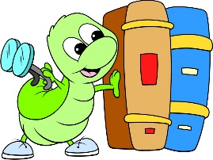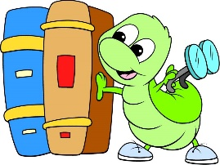

Reading Bingo

|  |  |  |  |  |
| --- | --- | --- | --- | --- |
| B | I | N | G | O |
|  |  |  |  |  |
|  |  |  |  |  |
|  |  | Free |  |  |
|  |  |  |  |  |
|  |  |  |  |  |